
Solution Architecture

Date | 26 June 2026
Team ID
Project Name | Smart Lender
Maximum Marks | 5 Marks

Solution Architecture Diagram:
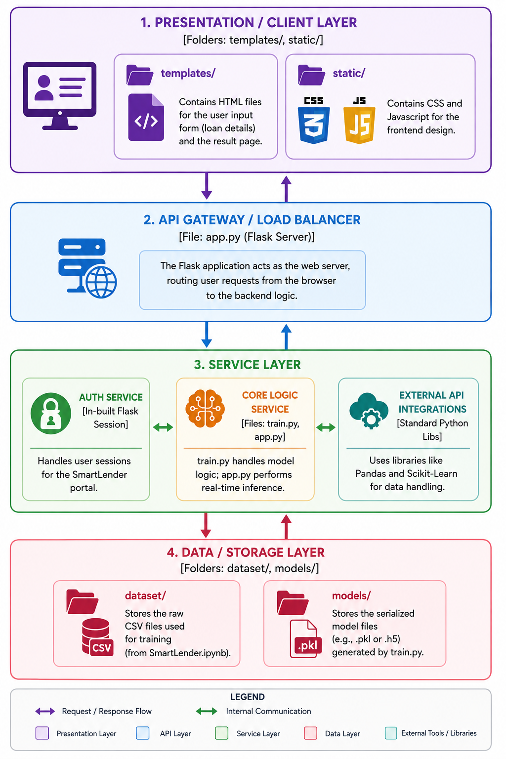



Component Description Table

Component Name | Description / Role in Architecture | Technologies Used
Presentation Layer | Provides a web-based user interface for bank officers or applicants to input loan details (e.g., Applicant Income, Credit History) and view the approval prediction result. | HTML5, CSS3, Jinja2 (Flask Templates)
Web Server / API | Acts as the bridge between the frontend and the ML model. It handles HTTP requests, validates user input from the forms, and triggers the prediction logic. | Flask (Python)
Core Logic Service (ML Inference) | Responsible for data preprocessing (handling missing values, scaling) and loading the trained model to predict the probability of loan approval. | Python, Scikit-learn, Pandas, NumPy
Data & Storage Layer | Stores the historical loan dataset used for training and the serialized model artifacts (saved .pkl files) required for real-time predictions. | CSV (Datasets), Pickle (Model Storage)

